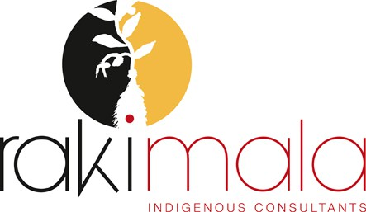

Service Rates:
 | Consultation Services | Research Services | Facilitation Services
Per 1 hr | $40 | $60 | $100
½ Day (3hrs) | $100 | $150 | $250
1 Day (6hrs) | $220 | $300 | $550

Translation Services | $25 per 100 words of translation from Yolngu matha to English

Consultation: Cultural advice and expertise around new initiatives, projects or events
Research: Design and conduct of community based research work
Facilitation: Design and conduct of cross-cultural training and/or other training workshops (eg. business skills, language learning)
Translation: Translation of video/audio/text from Yolngu matha to English

